Create an EventBridge rule with source event pattern as Success of Staging Glue Crawler and the Target as the “redshift_loader” Glue workflow created in the previous step.

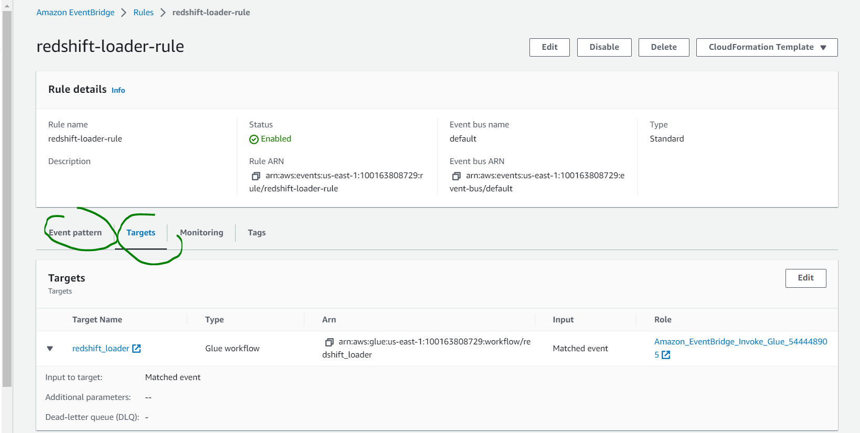

In the source event pattern, I had to manually add the “crawlerName” i.e. I was not provided the option to select the Glue crawler whose state change I was looking for, to trigger the Glue workflow.

